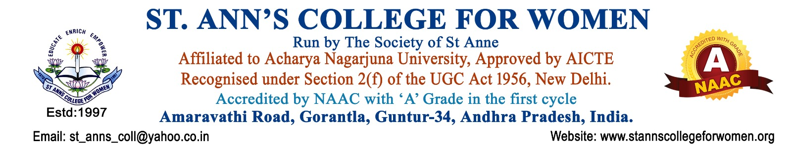

MCA – Master of Computer Applications
Advanced Computing • Software Development • Innovation
The MCA (Master of Computer Applications) programme at St. Ann’s College for Women is designed to prepare students for successful careers in the rapidly evolving IT and software industry. The programme provides advanced knowledge in computer applications, programming, software engineering, database management, artificial intelligence, cloud computing, cybersecurity, and emerging technologies.
The curriculum combines strong theoretical foundations with practical training, project-based learning, internships, and industry-oriented skill development to help students become competent IT professionals and innovators.
Students gain hands-on experience through modern computer laboratories, seminars, workshops, coding practices, and real-time software projects that enhance technical expertise and problem-solving abilities.
Presently offered as a Two-Year Postgraduate Programme.
Programme Highlights
- Advanced Programming & Software Development
- Artificial Intelligence & Data Analytics
- Cloud Computing & Cybersecurity
- Database Management Systems
- Web & Mobile Application Development
- Industry-Oriented Projects & Internships
- Research & Innovation Opportunities
- Skill Development for IT Careers
Career Opportunities
Graduates of the MCA programme can pursue careers as:
- Software Developer
- Web & Mobile App Developer
- Data Analyst
- System Analyst
- Database Administrator
- Cybersecurity Professional
- Cloud Solutions Associate
- IT Consultant
- Software Tester
- Research & Academic Professional
Why Choose St. Ann’s College for MCA?
- Experienced Faculty & Industry Exposure
- Modern Computer Labs & Digital Learning Facilities
- Practical & Research-Oriented Teaching
- Career Guidance & Placement Support
- Workshops, Seminars & Technical Events
- Holistic Development & Professional Training
Future Prospects
The MCA programme opens pathways to careers in leading IT companies, software industries, startups, research organizations, government sectors, and higher studies in computer science and technology.
Contact Us
St. Ann’s College for Women
Gorantla, Guntur – 522 034
📞 0863-2236470
📱 73821 04655, 85006 56134
🌐 www.stannscollegeforwomen.ac.in
Admissions Open 2026–27

